University Of Engineering and Technology, Lahore
Computer Engineering Department

Course Name: Programming Fundamentals | Course Code: CMPE-112L
Assignment Type: Lab Report | Dated:
Semester: 1st | Session: 2026 Spring
Lab/Project/Assignment #: 8 | CLOs to be covered: CLO
Lab Title: Recursion | Teacher Name: Hafiz Muhammad Mubashar
Lab Evaluation:

CLO1 | Apply appropriate programming techniques to create executable programs to solve well defined problems
 | Level1 | Level2 | Level3 | Level4 | Level5 | Level6
(5)
Total |  |  |  |  |  | /5
Rubrics for Current Lab Evaluation
Scale | Marks | Level | Rubric
Excellent | 5 | L1 | Submitted all lab tasks, BONUS task, have good understanding.
Very Good | 4 | L2 | Submitted the lab tasks but have good understanding
Good | 3 | L3 | Submitted the lab tasks but have weak understanding.
Basic | 2 | L4 | Submitted the lab tasks but have no understanding.
Barely Acceptable | 1 | L5 | Submitted only one lab task.
Not Acceptable | 0 | L6 | Did not attempt
LAB No 1
Lab Goals/Objectives:
• Understand the concept of recursion.
• Learn to write recursive functions.

Equipment Required:
• Computer/Laptop
• Python 3.x
• IDE (IDLE, VS Code, or PyCharm)

Theory:
Recursion is a programming technique in which a function calls itself to solve a problem. Every recursive function must have a base case to stop the recursion and prevent infinite function calls. It is commonly used for problems that can be divided into smaller subproblems.

Lab Work:

Recursion:

Task 1:
def n (a,b):
s = a+b
return s
v=n (1,2)
print(v)

Result:
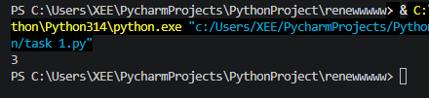

Task 2
def show (n):
print(n)
if (n == 0):
return

show (n - 1)

show(6)
Result:
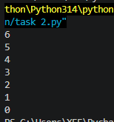

Task 3:
def show(n):
if (n==0) or (n==1):
return 1
else:
return show(n - 1)
print(show(6))

Result:
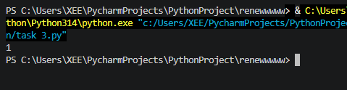

Conclusions:

In this lab, we learned how recursion works by creating recursive functions. We also understood the importance of the base case and how recursion can simplify solving certain programming problems.

